**Installation of WildFly Through Ansible Playbook on Ubuntu**

* Firstly, create two instances in EC2(one as ‘Ansible Master’ and another as ‘Node-1’).
* Add same user in both the VM (Virtual Machines) with same password. e.g., “shoaib”.

**$ 🡪 (sudo adduser shoaib)**

* Add the user being in “Ubuntu” into sudoers file below “sudo” and write

“username ALL=(ALL:ALL) NOPASSWD:ALL”

**$ 🡪 (sudo visudo)**

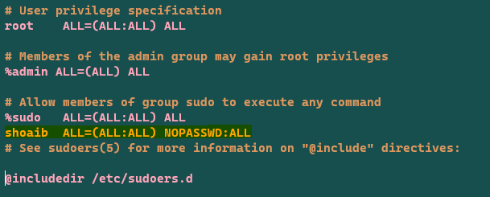

* Change the authentication from “no” to “yes” in sshd_config at “PASSWORD AUTHENTICATION”.

**$ 🡪 (sudo vi /etc/ssh/sshd_config)**

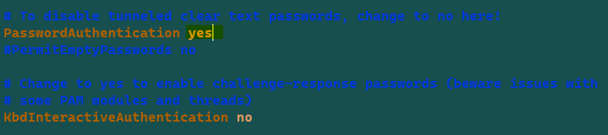

* Restart the sshd service.

**$ 🡪 (sudo service sshd restart)**

* Check the status of sshd service. (It will show as “Running”)

**$ 🡪 (sudo service sshd status)**

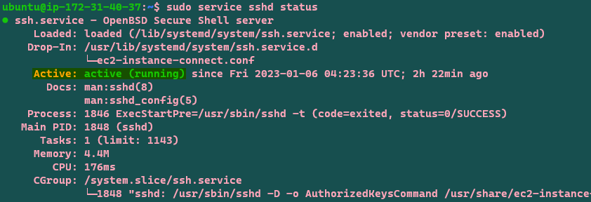

* Run the above steps in other VM (Node-1).
* Switch the user from “ubuntu” to “shoaib” in Ansible Control.

**$ 🡪 (su shoaib)**

* Generate the ssh key in “Ansible Master” being in user “shoaib”.

**$ 🡪 (ssh-keygen)**

* Then copy the ssh key into the other VM(Node-1).

**$ 🡪 (ssh-copy-id username@private_ip)**

* Now you can connect to the other VM(Node-1) without password from ‘Ansible Master’.

**$ 🡪 (ssh private_ip)**

* Update the cache in ‘Ansible Control’.

**$ 🡪 (sudo apt update)**

* Install Ansible in ‘Ansible Master’ to execute Ansible-Playbook in other VM(Node-1).

**$ 🡪 (sudo apt install ansible)**

* Create a directory as “wildfly-ubuntu” in user(shoaib).

**$ 🡪 (mkdir wildfly-ubuntu)**

* Go inside the directory.

**$ 🡪 (cd wildfly-ubuntu)**

* Create a file and name it as “hosts” and paste the private_ip of Node-1.

**$ 🡪 (sudo vi hosts)**



* Create another file and name it as “wildfly.yml” and paste the playbook which is written in vscode into “wildfly.yml” as shown below.

**$ 🡪 (sudo vi wildfly.yml)**

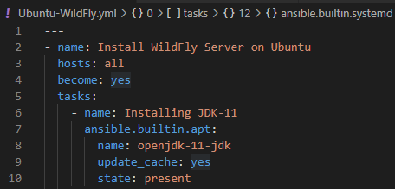

**Comment**: To write the playbook, first we need to understand the manual commands which we are going to execute to install any server/application, in this case refer here([https://www.hackerxone.com/2021/09/01/step-by-step-to-install-configure-wildfly-jboss-on-ubuntu-20-04/).](https://www.hackerxone.com/2021/09/01/step-by-step-to-install-configure-wildfly-jboss-on-ubuntu-20-04/).%20) Read and find the module in Ansible-Playbook with the required manual command, for example(<https://docs.ansible.com/ansible/latest/collections/ansible/builtin/apt_module.html>).

**Note**: Don’t write the whole playbook at a time, go step-by-step while executing any command as shown in the above screenshot.

* Run a command to check the syntax saved in the “wildfly.yml” is right or wrong. If this shows an error means that, there is something wrong in our playbook, then we need to go into “wildfly.yml” and do the necessary changes and run it again and again and again, until you see the message as shown below in the screenshot.

**Command 🡪 (ansible-playbook -i hosts –syntax-check wildfly.yml)**



* Now it’s time to execute the “wildfly.yml”.

**$ 🡪 (ansible-playbook -i hosts wildfly.yml)**

**Comment**: “-i” means check the inventory of “hosts” file and execute “wildfly.yml”, it will install the same thing for all the private ip_addresses present in the hosts’ file.

* If you see “changed=1” and it appears in yellow color means the installation of Java-jdk-11 has been done successfully.

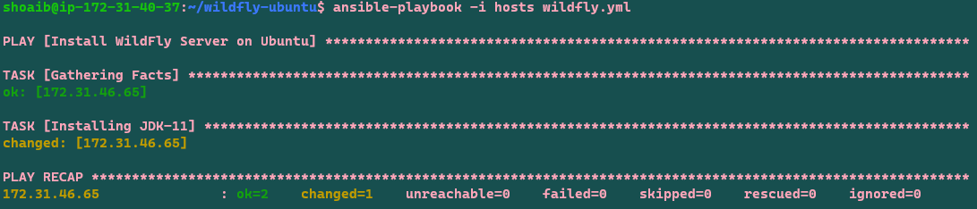

* If you see “changed=0” and other things appear in green color means the installation of Java-jdk-11 has been done already.
* After the above steps, cross-check that the Java-jdk-11 is installed in Node-1 by passing command “java --version” as shown below.



* Now go for the execution of other commands step-by-step as per the google document(<https://www.hackerxone.com/2021/09/01/step-by-step-to-install-configure-wildfly-jboss-on-ubuntu-20-04/>) and write the playbook as shown below by again editing the file “wildfly.yml”

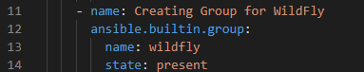.

**$ 🡪 (sudo vi wildfly.yml)**

**Note**: The above screenshot tells us that, we are creating a group for wildfly.

* Again, cross-check the syntax

**$** 🡪 **(ansible-playbook -i hosts --syntax-check wildfly.yml)**

* Then run “wildfly.yml”.

**$** 🡪 **(ansible-playbook -i hosts wildfly.yml)**

This time, it gives a result as shown below.

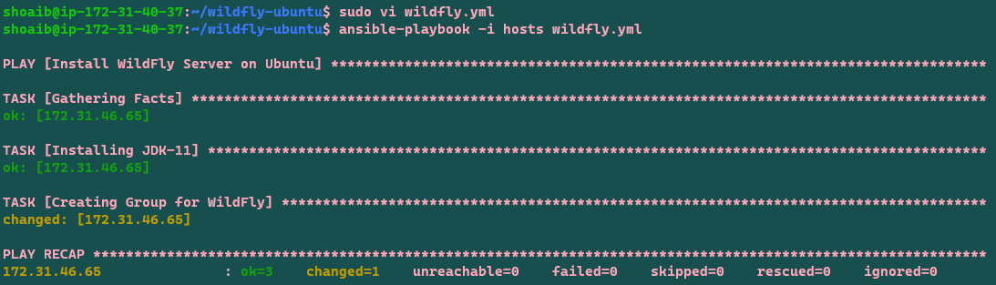

* Now, we need to do the above three steps (editing🡪wildfly, checking🡪syntax & running🡪 yaml file) until we get our assigned task.

**$ 🡪 (sudo vi apache.yml)**

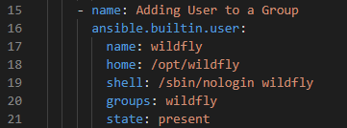

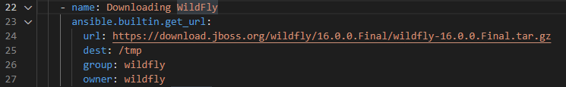

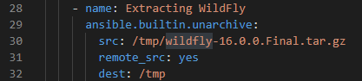

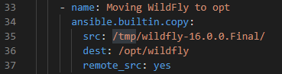

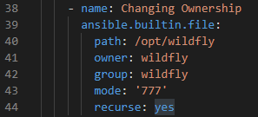

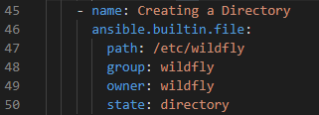

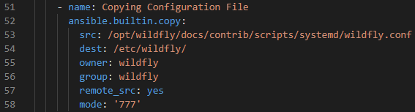

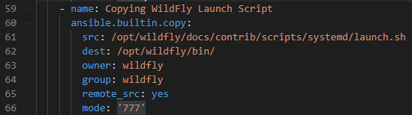



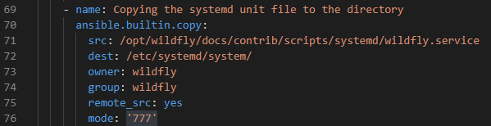

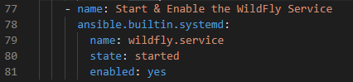

**Comment**: Be careful while executing the last command. Here, I was doing a minor mistake which hadn’t given me the required result. The mistake was, “I wrote ‘enabled: yes’ in the first place and ‘state: started’ at last”. The actual format is shown above which is writing ‘state’ firstly and ‘enabled’ secondly.

We can also observe that “Adding Execute Permissions to Shell Files” always gives us a result in yellow color, because we have used the “command module” and it always runs with the playbook.

* Check the status in “Node-1”. If it shows active(running) means the above playbook is working fine and if it shows “failed” means there may be some mistakes in the playbook which need corrections.

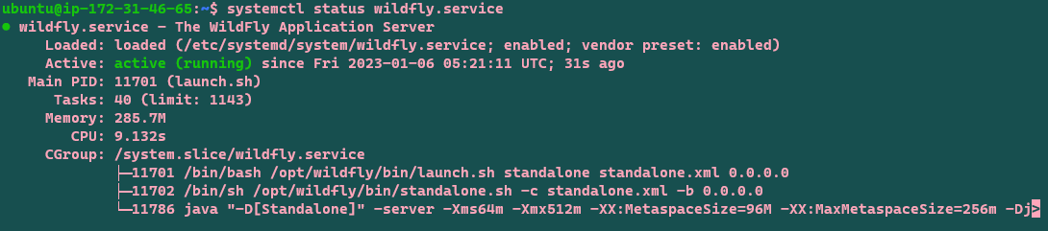

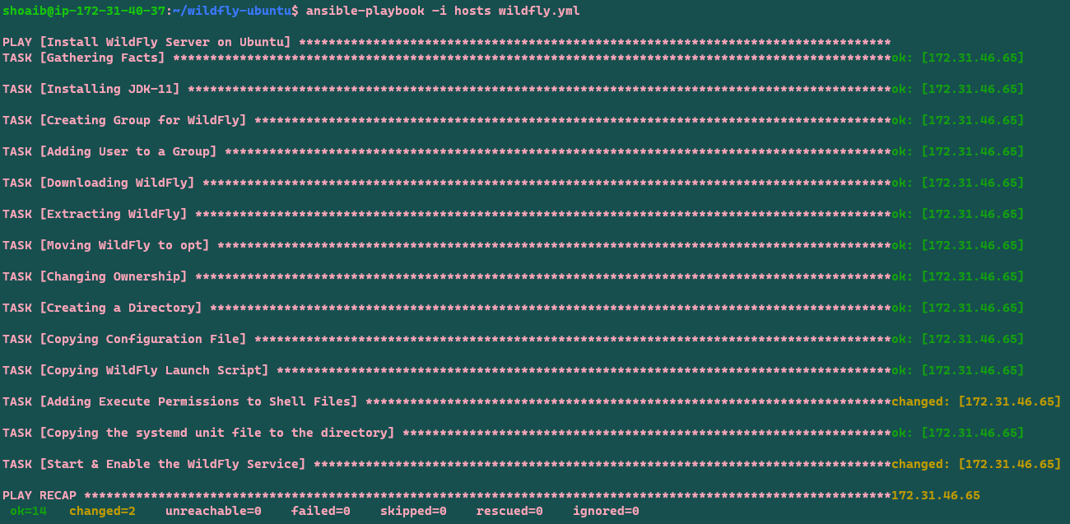

* Finally, we need to go to the application server page and after the public write colon 8080 “http://ip_address:8080”.

